QUERIES OUTPUT SNAPSHOTS FROM ORACLE ON OMEGA

*Query1*

*Before update:*

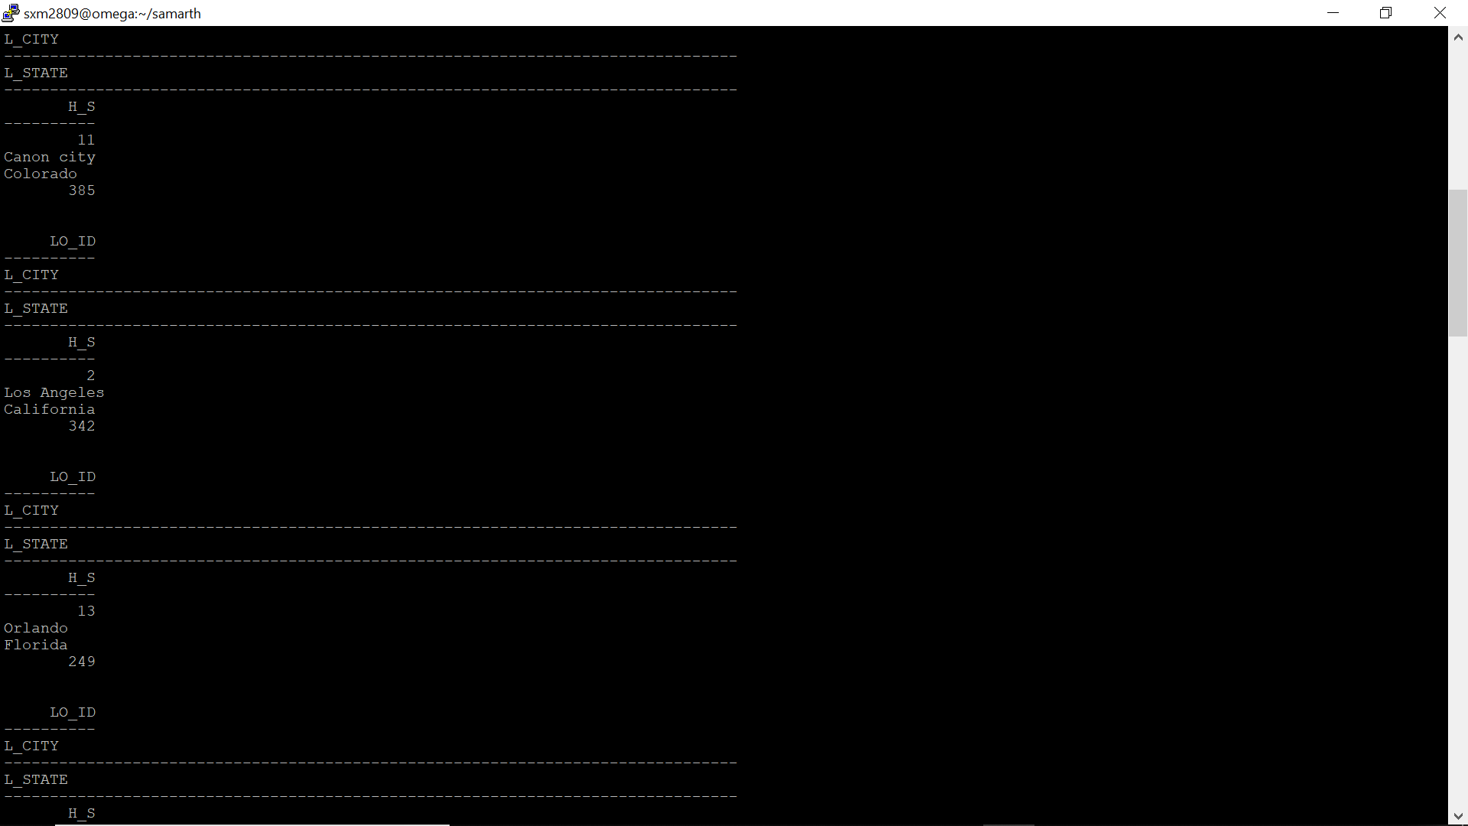

*After update:*

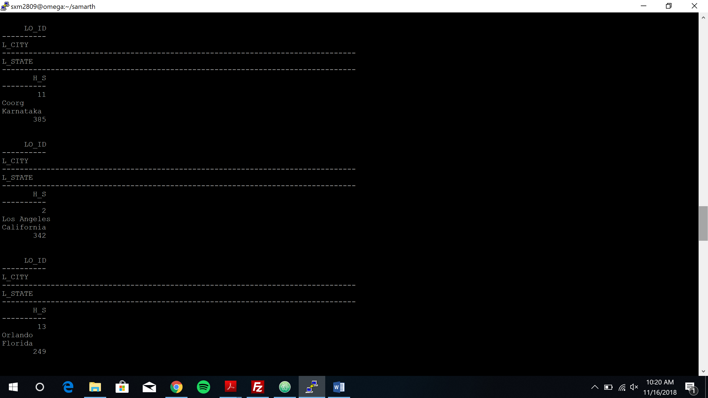

*Query 2:*

*Before update:*

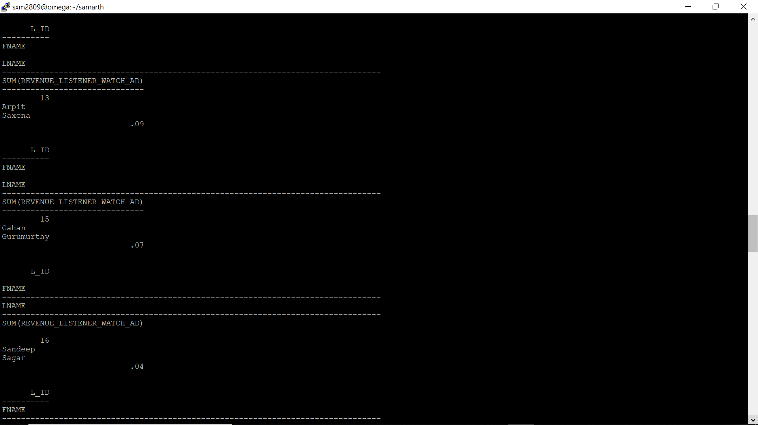

*After update:*

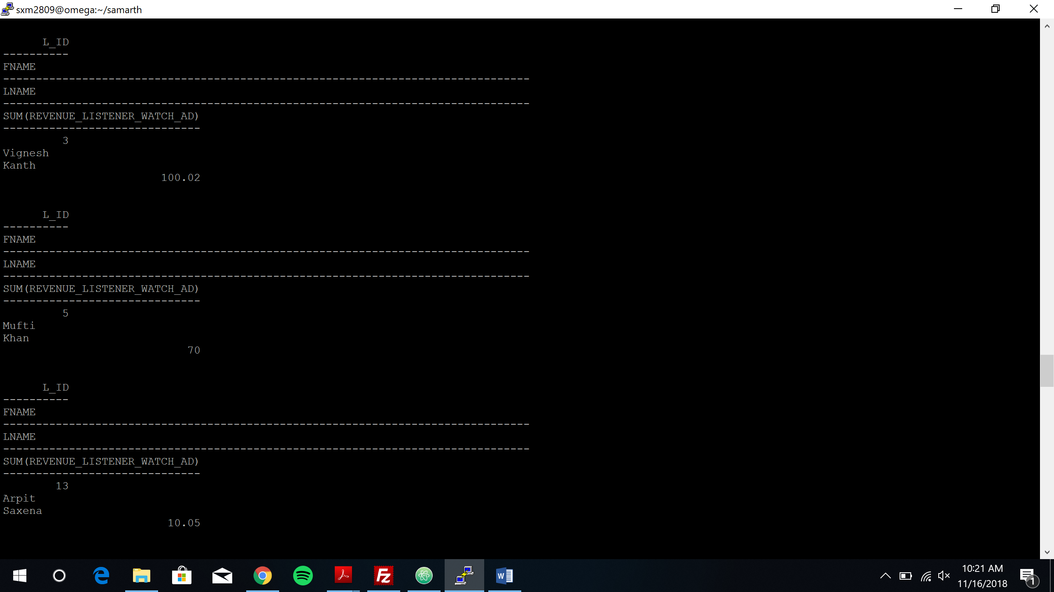

*Query 3:*

*Before update*

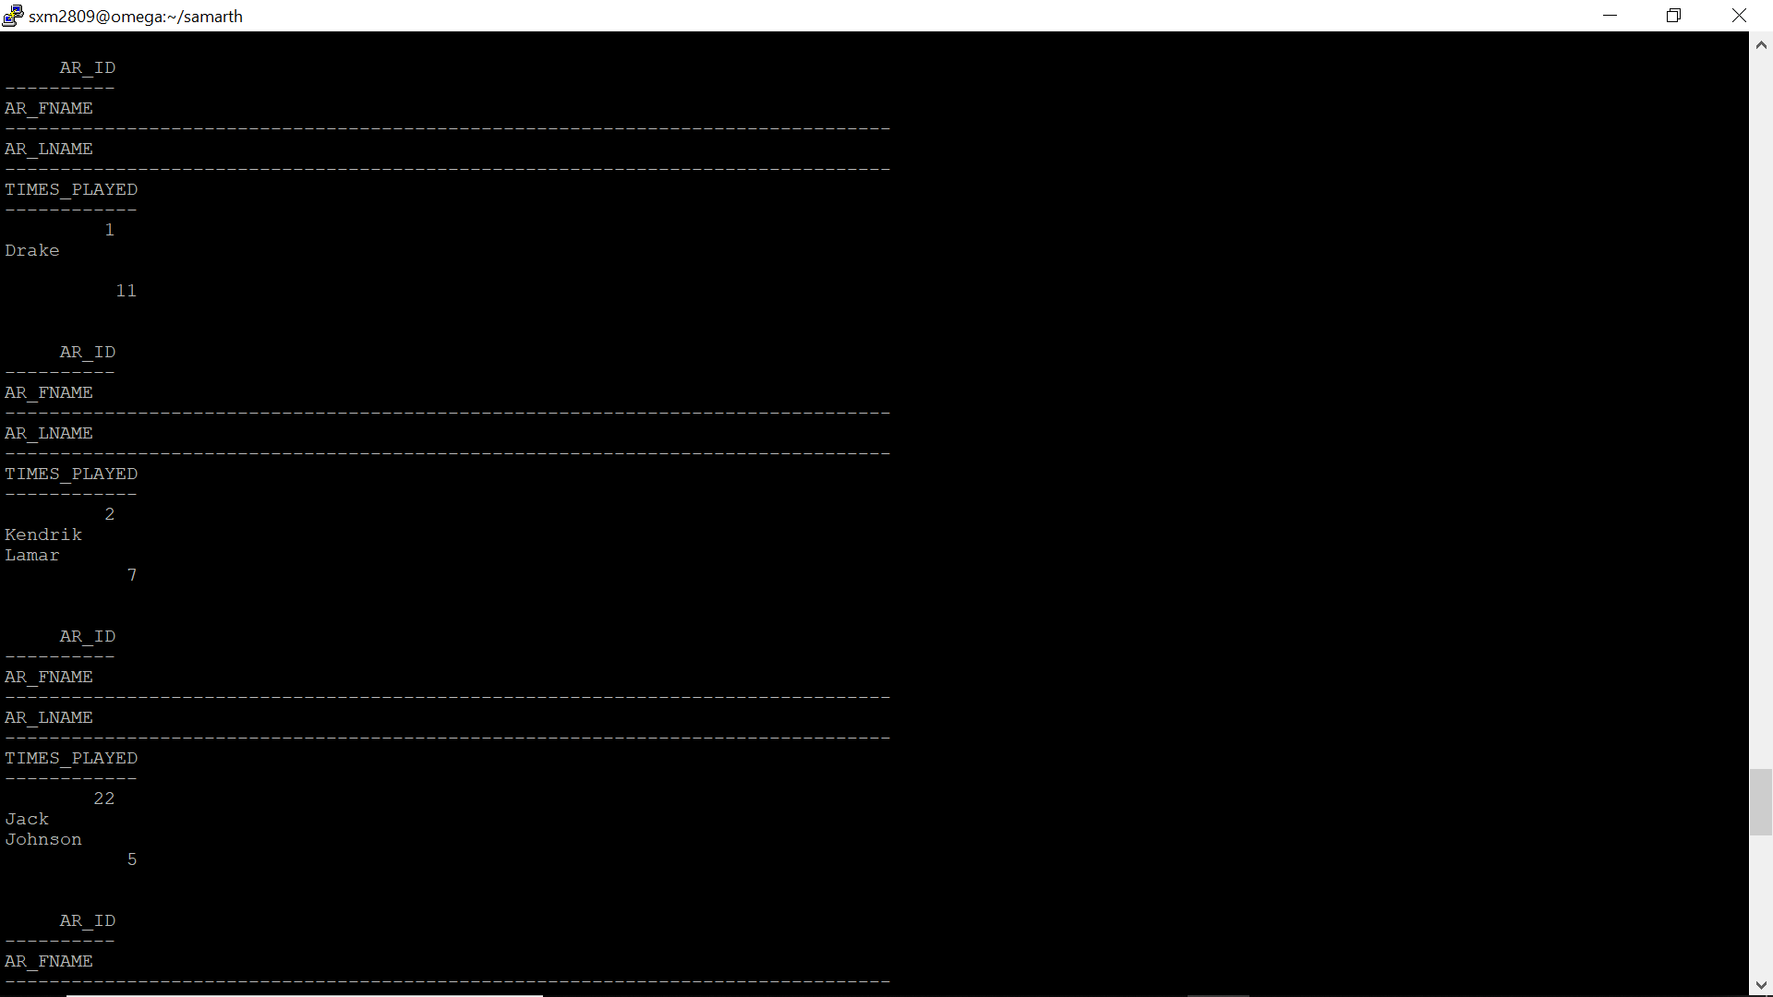

*After update:*

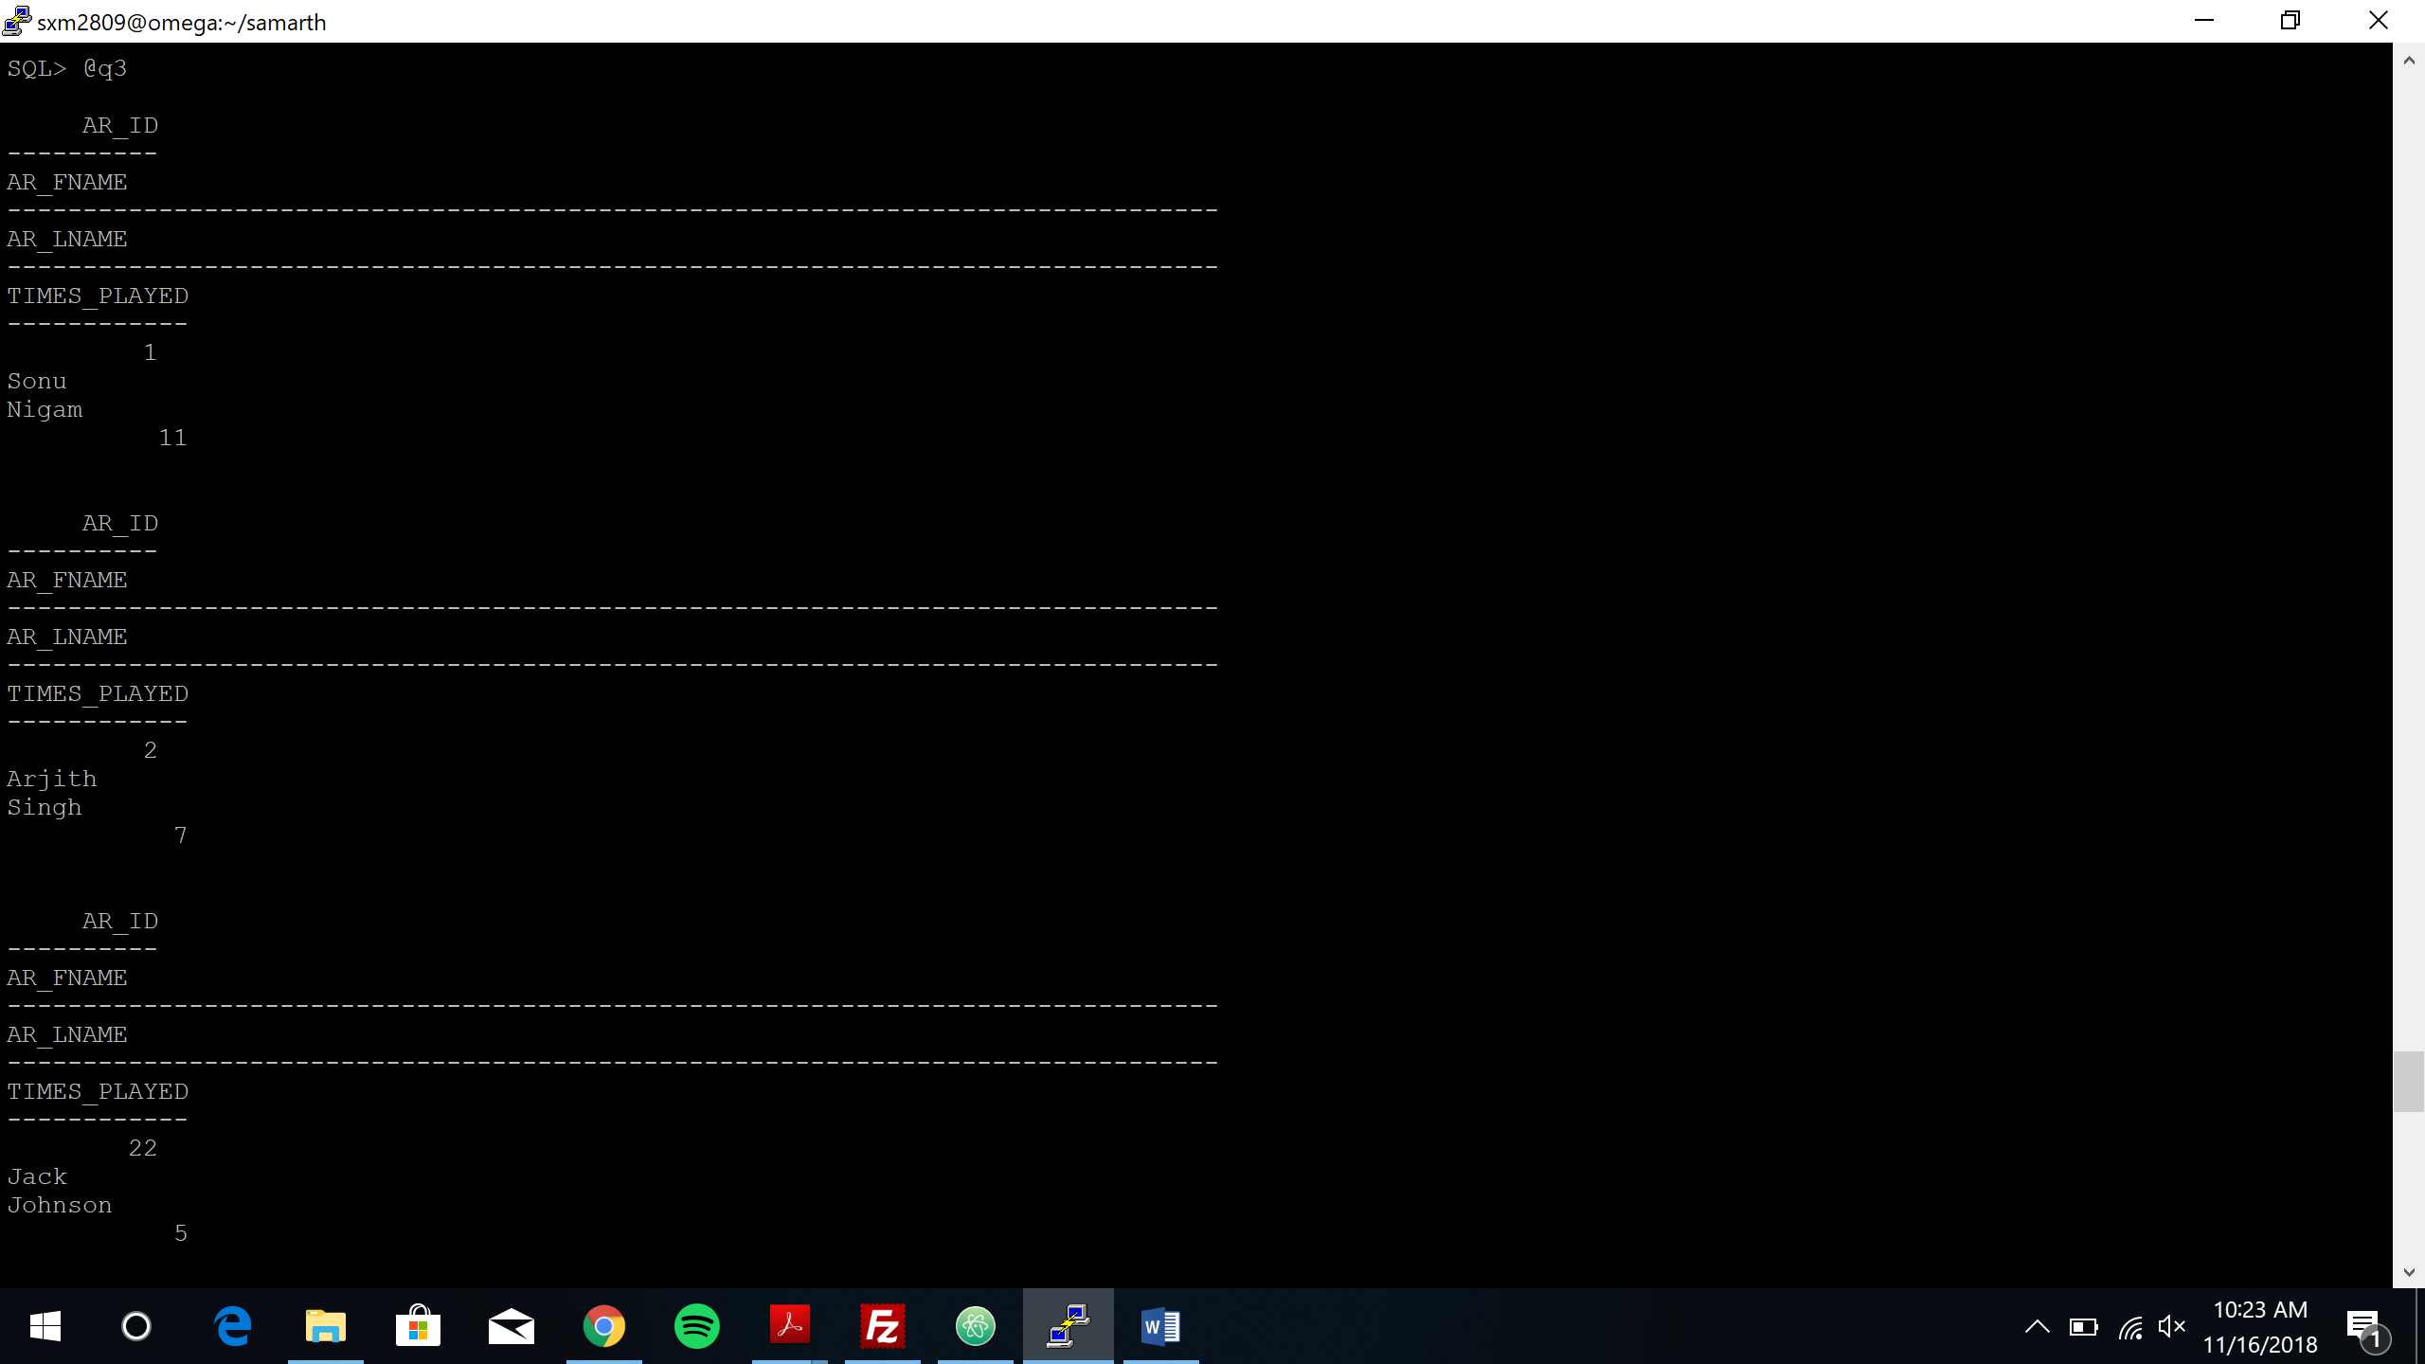

*Query 4:*

*Before update:*

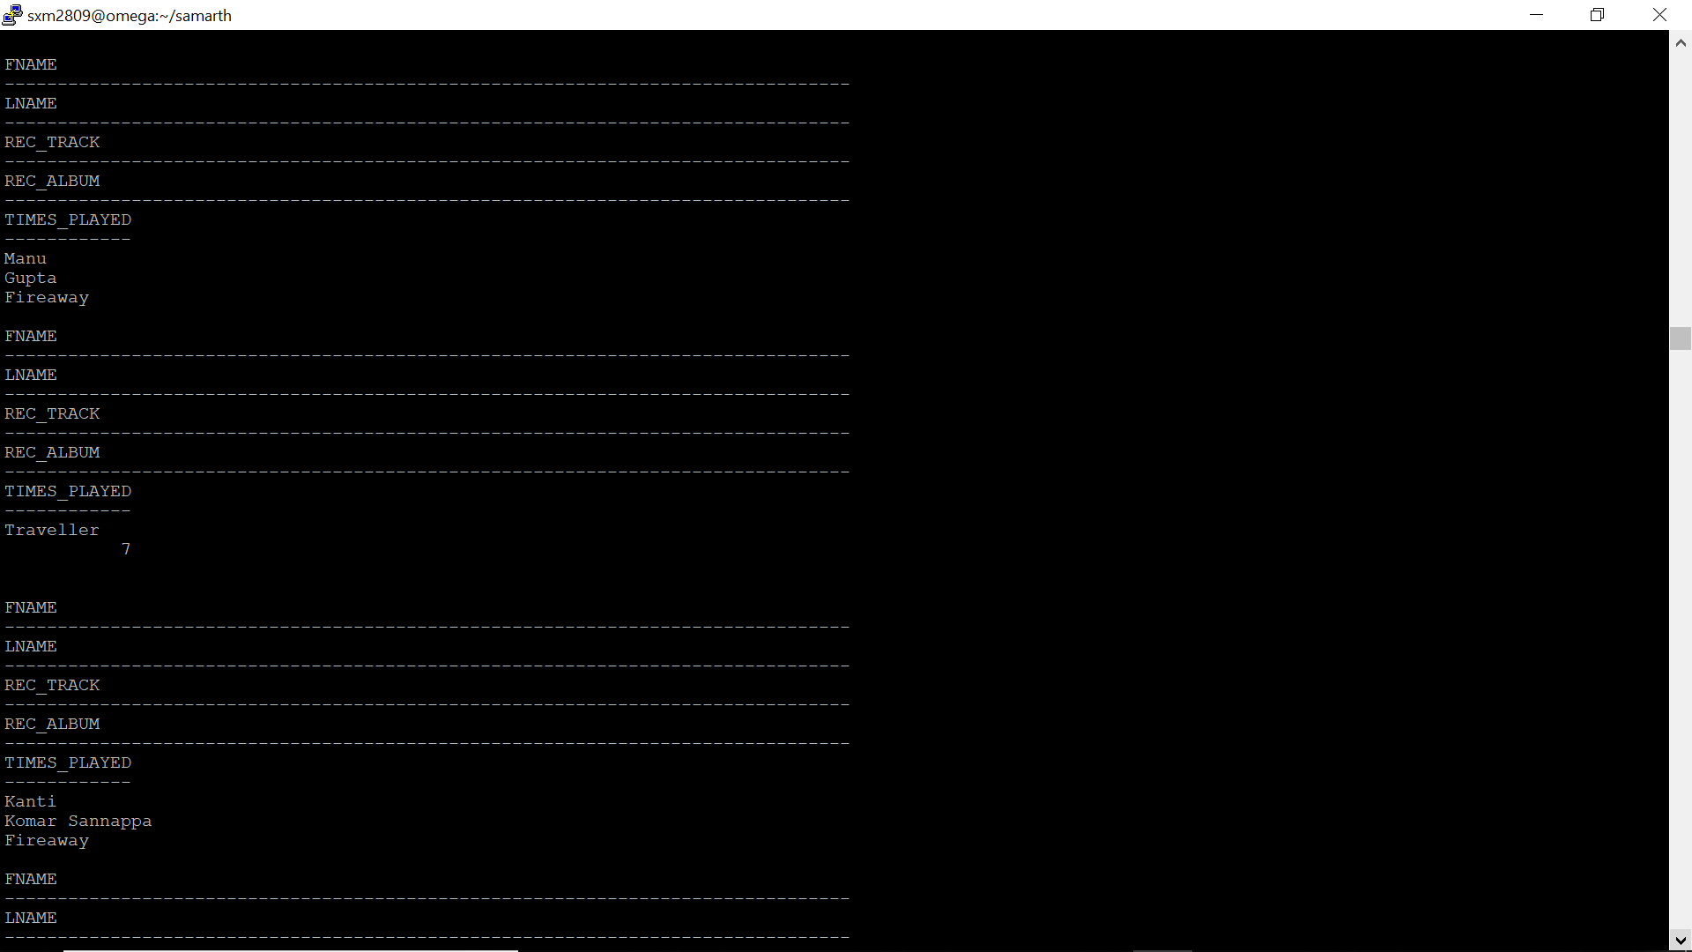

*After update:*

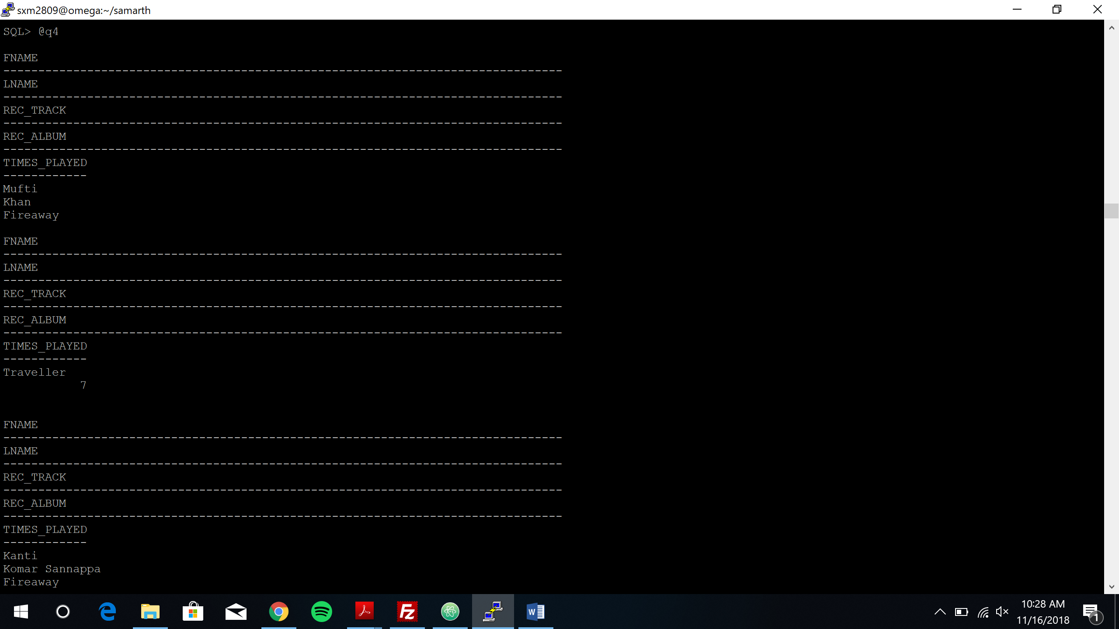

*Query 5:*

*Before update:*

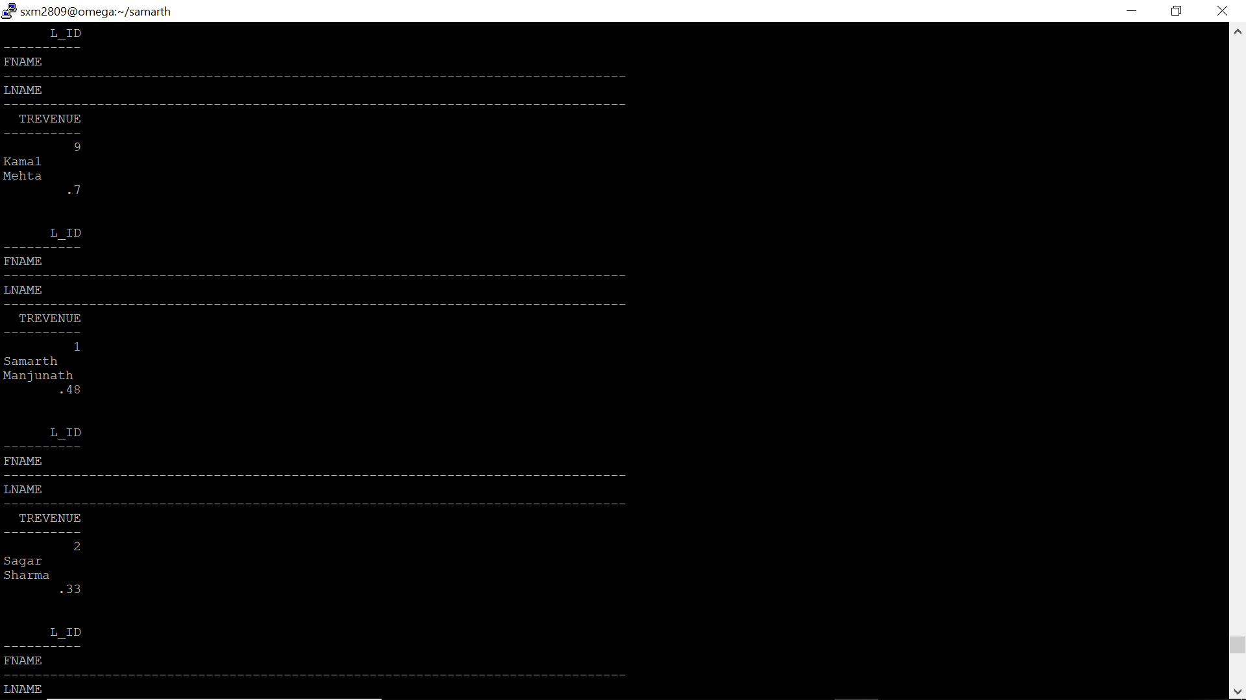

*After update:*

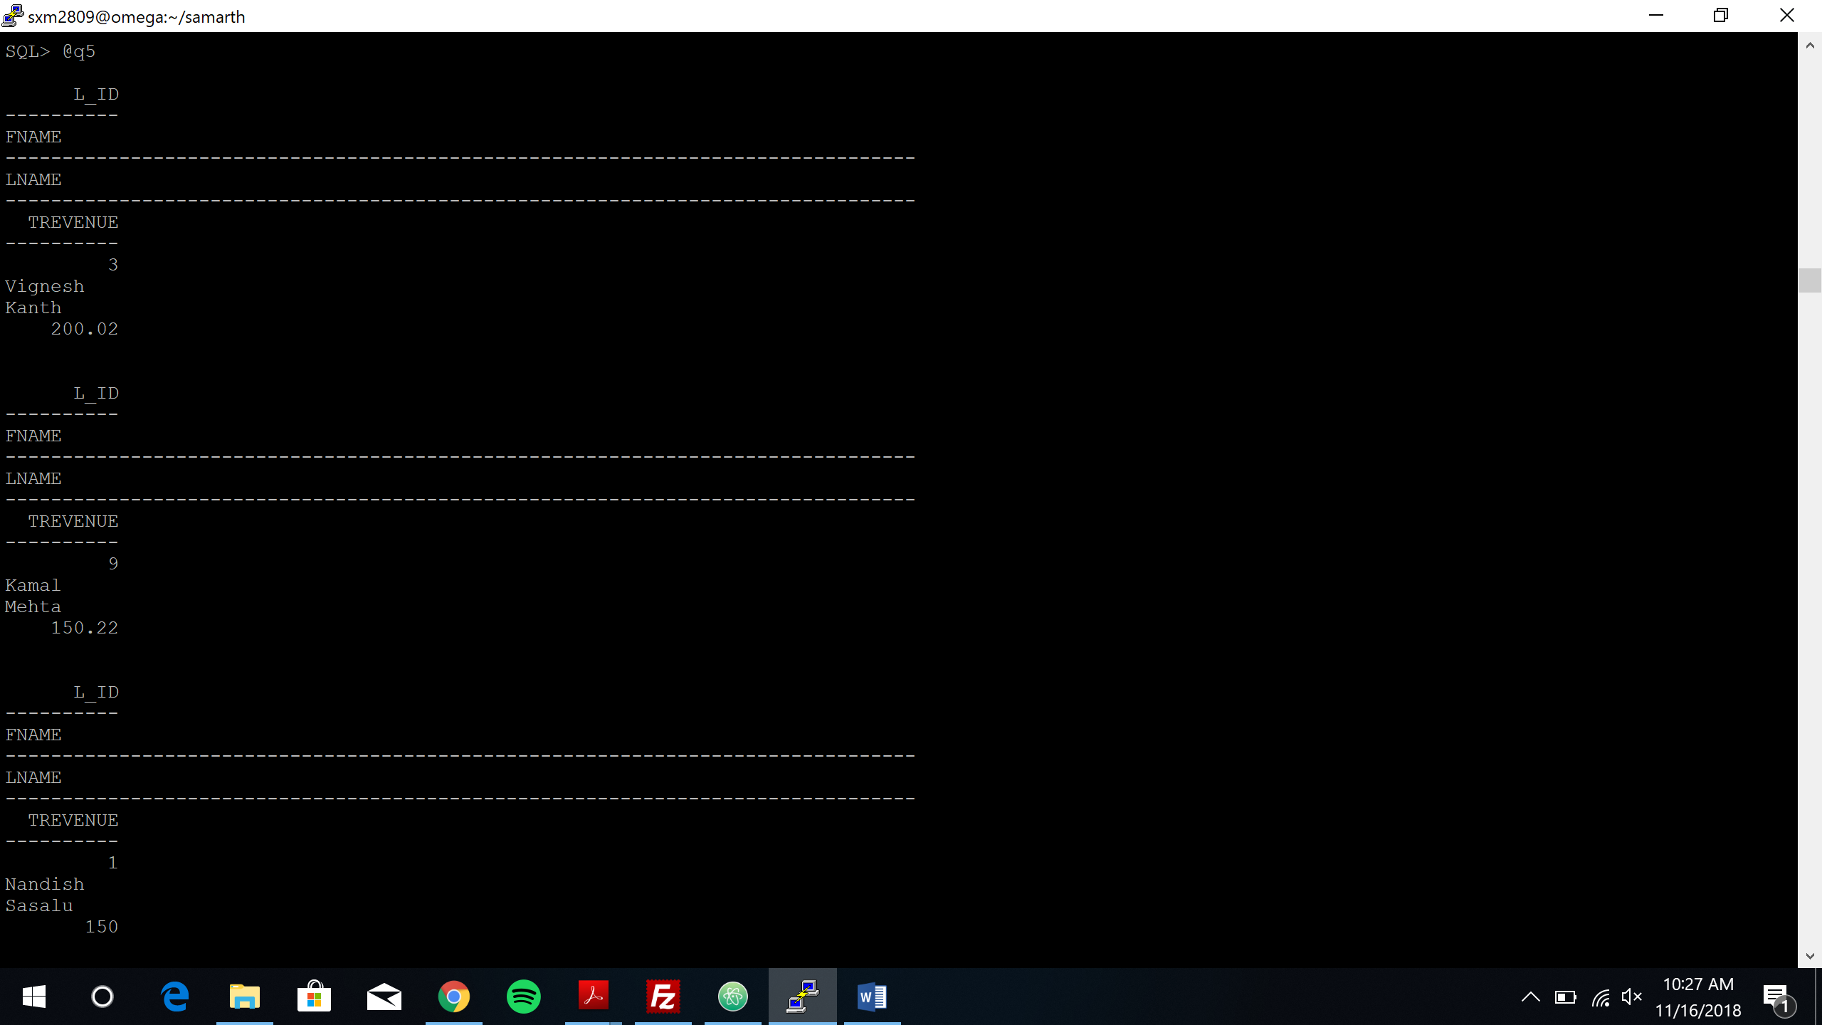

*Query 6:*

*Before update:*

*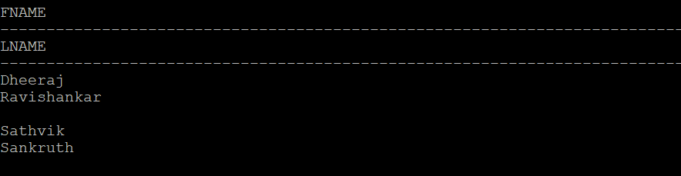*

*After update:*

*Query 7:*

*Before update:*

*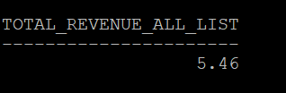*

*After update:*

*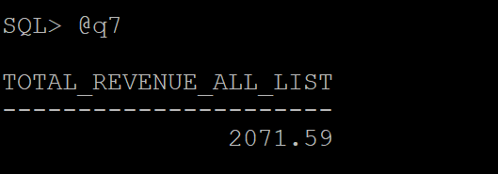*

*Query 8:*

*Before update:*

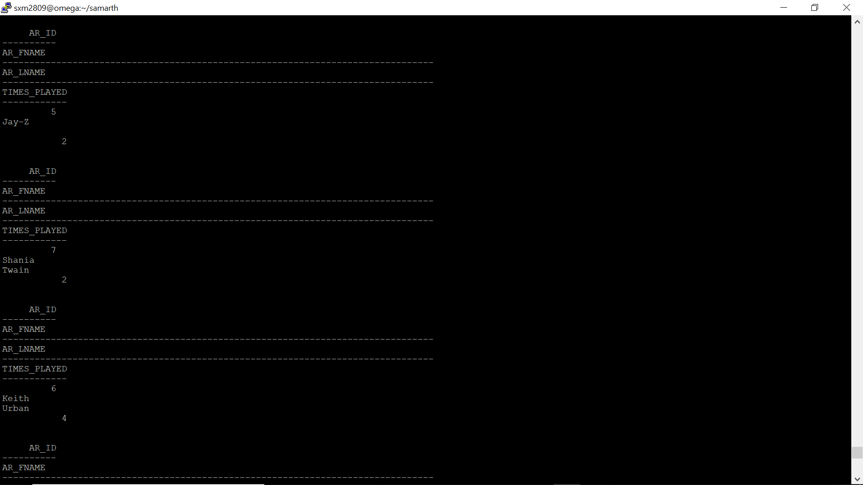

*After update:*

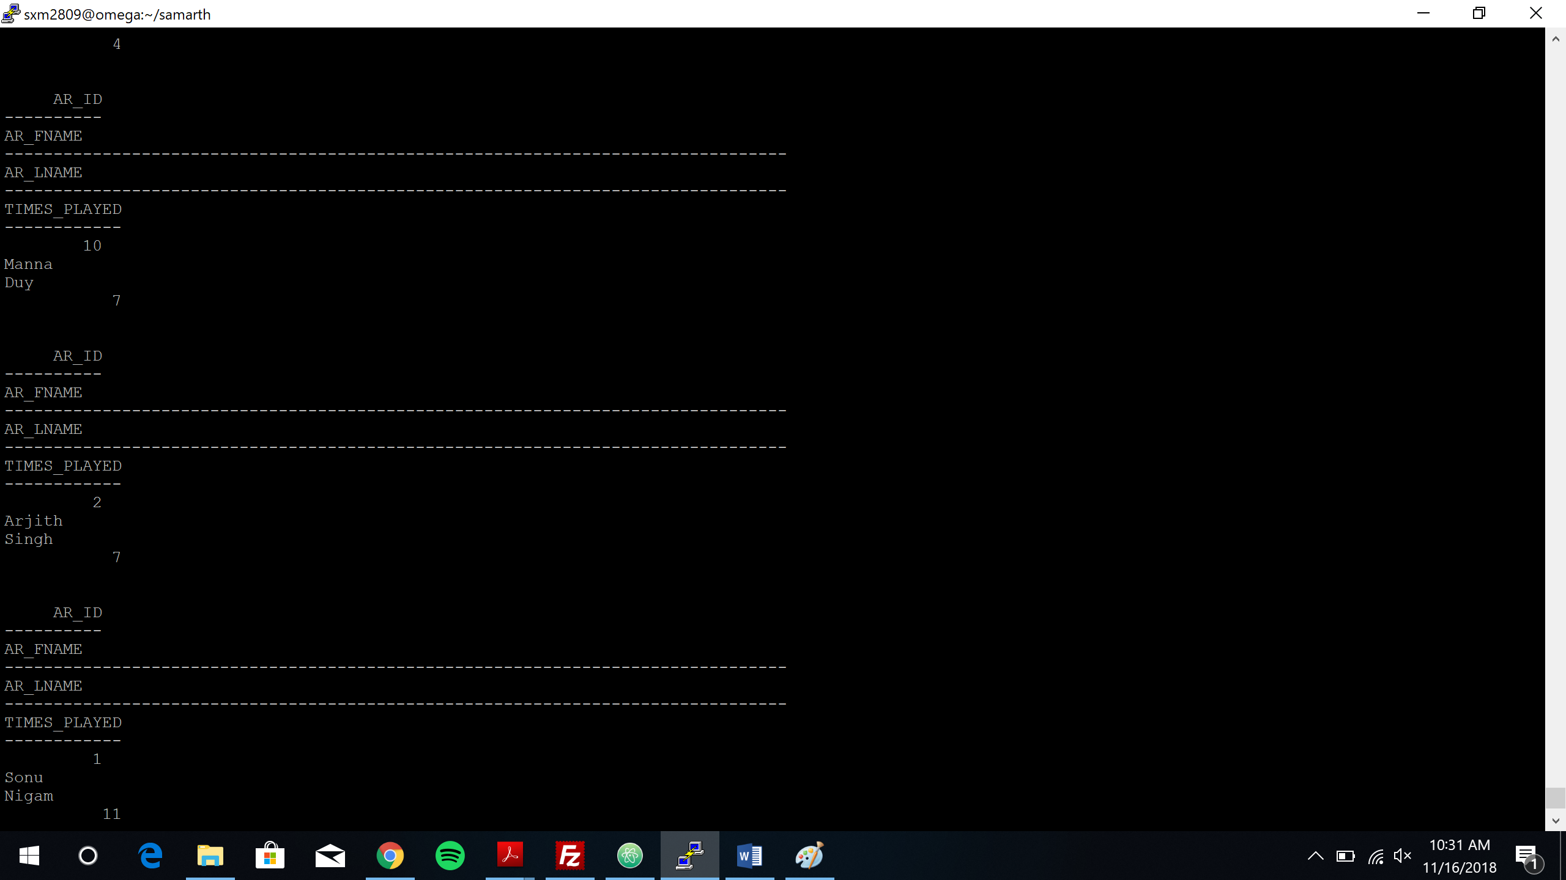

*Query 9:*

*Before update:*

*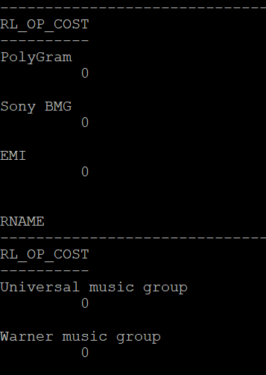*

*After update:*

*Query 10:*

*Before update:*

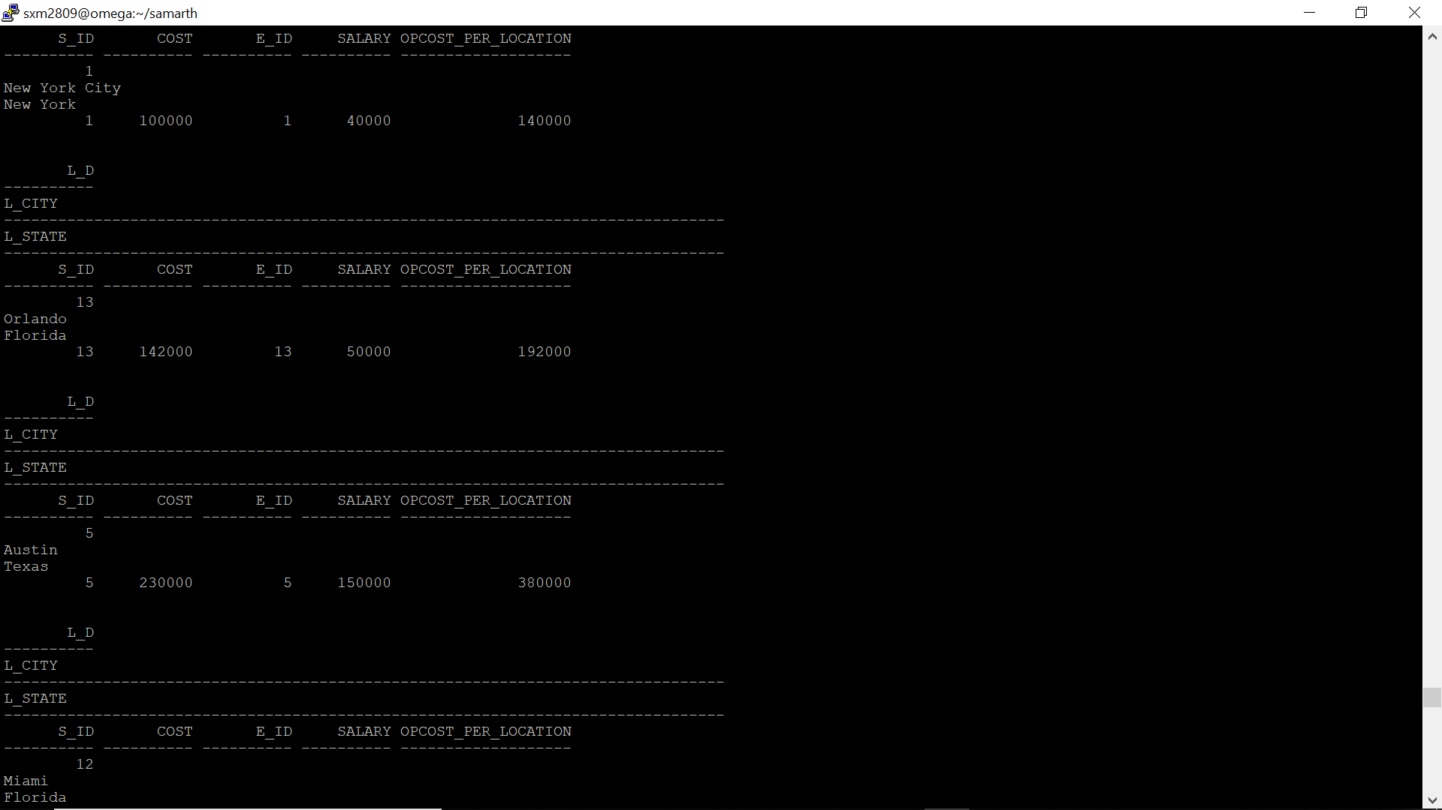

*After update:*

